# Exercise: Selenium Advanced

This document defines the homework assignments from the ["QA Automation" Course @ Software University](https://softuni.bg/trainings/2550/qa-automation-may-2020).

Please submit as homework a single zip / rar / 7z archive holding the source code or whatever approach is needed to finish your tasks

## Automationpractice Registration negative tests

After the last test, you can be sure that the registration page opens correctly. Now for the next tests you can navigate directly to <http://automationpractice.com/index.php>**.** Write at least **five negative tests** against the registration form. Your tests must check **five** **different error messages**.

### Examples

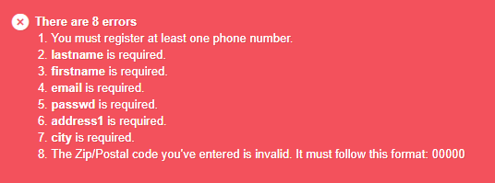

## Interaction Tests

Write some tests for every page in the **interaction sections** in the<https://demoqa.com/> website. There is a **minimum number** of tests for each page in the interaction section:

* **Draggable - 3 tests**
* **Droppable - 3 tests**
* **Resizable - 2 tests**
* **Selectable - 2 tests**
* **Sortable - 2 tests**